Building the AllJoyn WinRT Samples on different platforms

The AllJoyn WinRT samples are configured by default to build for 64-bit, this document is meant to help developers build for the desired platform (Win32, x64, ARM.)

# Configuring the solution to build for the right platform

Next, configure the solution to build for the target platform by opening the Configuration Manager. Open the Configuration Manager (from the menu bar, select “Build” then “Configuration Manager…”.) Change the “Active solution platform” dropdown control to match the desired target platform. Figure 1 shows the solution is now configured to build for Win32.

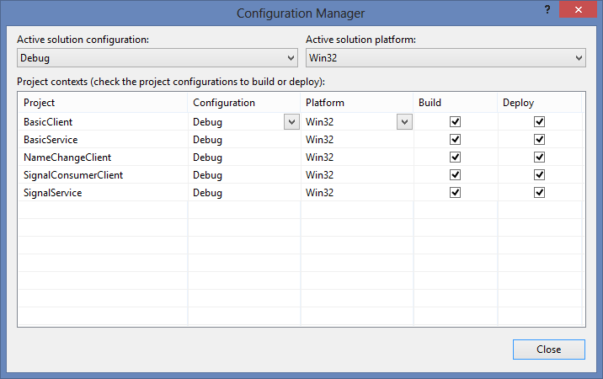

Figure 1 Configuration Manager (Solution is now ready to build for 32-bit)